DESIGN OF AN UNDERSEA OIL MULTIPHASE FLOW MEASUREMENT BY THE PROMPT GAMMA RAY NEUTRON ACTIVATION ANALYSIS APPROACH

Experimental Benchmarking Of CEARCPG Code

L. Beth Ammons
Andrew F. Colhoun
Vincent A. Di Nova Jr.
Colin A. Lancaster
Alison A. Parpal
Carson C. Swanek
Hester Z. Wan

Dr. Robin P. Gardner

North Carolina State University
Department of Nuclear Engineering
Raleigh, North Carolina
ABSTRACT

The specific-purpose Monte Carlo code CEARCPG has recently been developed at N.C. State’s Center for Engineering Applications of Radioisotopes for simulating prompt gamma-ray neutron activation analysis (PGNAA). CEARCPG may be used with the Monte Carlo – Library Least-Squares (MCLLS) measurement approach for identifying the composite constituents of bulk samples. Studies at CEAR and elsewhere have indicated that PGNAA may find application in the oil industry, which seeks a rapid and effective method of identifying the multiphase contents of wells during undersea drilling operations (Mutiso et. al. 2007). These previous studies have treated both three-phase and four-phase problems, analyzed by the MCLLS method using both elemental and composite material libraries. In the study at hand, a physical apparatus for benchmarking a four-phase study of oil, water, salt, and gas has been designed. In addition, a four-phase multiphase flow measurement meter has been designed that is appropriate for deployment within existing undersea drilling operations. Calculations made with MCLLS in conjunction with CEARCPG support that the implementation of PGNAA in industry can enable fast and accurate measurement of the proportion of liquids and gases contained within drill pipes during oil extraction.

TABLE OF CONTENTS

Introduction…………………………………………………………………………………..
Methods and Procedure………………………………………………………………………
Results………………………………………………………………………………………..
Discussion…………………………………………………………………………………….
Conclusion……………………………………………………………………………………
References…………………………………………………………………………………….
Appendix…………………………………………………………………………………….

INTRODUCTION

Problem Statement

The Center for Engineering Applications of Radioisotopes (CEAR) at North Carolina State University has been instrumental in the development of numerous processes, techniques and tools for use in the broad field of radioisotope application in industry, medicine and research. A recent development of N.C. State’s CEAR is the specific-purpose Monte Carlo code CEARCPG, capable of simulating neutron capture, elastic, and inelastic scatter reactions, and useful for modeling bulk material analysis by PGNAA.
A promising application for analysis by PGNAA exists within the deep-sea oil drilling business. This industry seeks a rapid and effective method of identifying the multiphase contents of wells during undersea drilling operations. PGNAA is suitable for this type of work environment because it is robust and highly transportable, is capable of measuring considerable volumes in a short period, and is nondestructive (Han et. al. 2007). Calculations made with the previously developed Monte Carlo – Library Least-Squares (MCLLS) measurement approach in conjunction with CEARCPG support that the implementation of PGNAA in industry can enable fast and accurate measurement of the proportion of liquids and gases contained within drill pipes during oil extraction.
There are two interdependent components of the study at hand. In the first phase, a physical system is designed and constructed to model an undersea oil pipe containing a homogeneous mixture of known proportions of water, salt, oil and gas. This bench-top experimental apparatus, outfitted with a Cf-252 neutron source, Cs-137 gamma ray source, and a 6x6 inch sodium iodide detector, is used to experimentally test the accuracy and effectiveness of CEARCPG for computational modeling of this type of system. In the second phase, an undersea PGNAA Flow Analyzer is designed using the theories and physics associated with the bench-top design study. The Flow Analyzer will be capable of rapid integration into new and prefabricated undersea drilling lines and will serve as a means of identifying flow components at the surface in real time during oil extraction.
The objectives, constraints, and variables associated with this design project, along with the experimental and simulated results obtained, are presented within the body of this report.

PGNAA

Prompt gamma ray neutron activation involves the identification and analysis of prompt gamma rays emitted following the radiative capture of neutrons by a target material. All isotopes of all elements, except for the alpha particle ⁴He, can undergo radiative neutron capture, allowing for extremely thorough analysis of any bulk material by neutron irradiation and subsequent gamma spectroscopy. The technique of employing PGNAA for elemental analysis of material samples was first proposed by György Hevesy in 1936, and has become fairly standard as the experimental determination and accurate tabulation of gamma-ray energies has progressed and improved (Molnar, 2004).
PGNA analysis allows the user to discern the chemical makeup of a target material through the analysis of characteristic prompt gamma rays generated by neutron interactions within the material. PGNAA analysis is particularly useful for identification of especially small volumes of distinct elements in a mixed sample (Young and Freedman, 2004).

CEARCPG

The Center for Engineering Applications of Radioisotopes (CEAR) at North Carolina State University has been instrumental in the development of numerous processes, techniques and tools for use in the broad world of radioisotope application in industry, medicine and research. A recent development of N.C. State’s CEAR is the specific-purpose Monte Carlo code CEARCPG for PGNAA of bulk materials.
A prompt gamma-ray emission spectrum generated for any material sample is unique to the chemical composition by volume percent of the contents of the sample. In this study, gamma ray spectral data will be generated by experiment and also by CEARCPG. These two data sets will compared using the Monte Carlo Linear Least Squares approach to help determine the accuracy of CEARCPG in modeling this type of system. Adjustments to the apparatus will be made as necessary to ensure agreement between CEARCPG and experimental output and to prepare CEARCPG for application in industry.
Advancements have been made in the spectral source data available for use in PGNAA from the first published energy and intensity table by Groshev et. al. in 1961 to the most modern neutron capture data tabulation performed by IAEA in 2004 (Molnar 2004). The source data utilized in CEARCPG are similar to those utilized in Monte Carlo n-Particle (MCNP).

Figure XXX: Comparison of sources of Nuclear Source Data and Nuclear Interaction Treatment in CEARCPG and MCNP (Han et. al., 2007)

 | CEARCPG | MCNP
Nuclear data | ENDF/B-VI  ENSDF  EPDL | ENDF/B-VI with NJOY format  EPDL
Neutron interaction | Neutron capture reaction | Same
Neutron interaction | Neutron elastic scattering reaction (Free gas thermal Treatment) | Same
Neutron interaction | Neutron inelastic scattering reaction (n, n’ γ) | All inelastic scattering reaction, such as (n.n’) (n,2n) etc.
Generation of neutron-induced photons | Sampling from isotope scheme | The number is function of neutron weight, photon limit weigh, photon production cross section, etc.  Expanded photon production method & 30x20 photon production method
Photon interaction | Simple Physics Treatment | Simple Physics Treatment &  Detailed Physics Treatment
Variance reduction technique | Stratified sampling | General

Monte Carlo Linear Least Squares

The linear least squares code is utilized to validate results from both the output from the CEARCPG code, put into phase libraries, and the experimental spectrum. The linear least squares code takes the experimental data and tries to match a combination of the phase libraries that minimizes the area between the two spectrums. The output of the linear least squares code gives errors associated with each phase and the relative amount of the phase in the system. The error is calculated in the following manner:
The error in each channel, E_{i} , is given as the following equation;
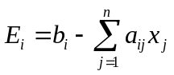 i=1,n (1)
Where b_{i} is the counting rate in counts per second for each channel i, a_{ij} is the counting rate in channel i per unit amount of library component j. x_{j} can be obtained with a known a and b by minimizing the sum of the squares of the random errors in all channels.
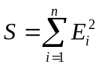 (2)
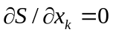 (3)
This leads to a system of equations that is solved for by using a matrix inversion. The standard deviation of each calculated amount is given by:
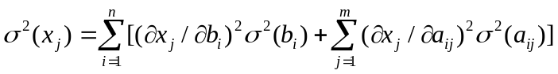 (4)
When 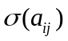 is negligible then:
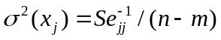 (5)
Where 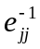 is the element jj of the inverted matrix. When weighting factors are used for each channel, Poisson statistics gives a χ² value instead of the sum of the squares.
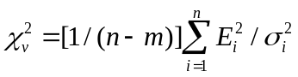 (6)
If the calibration of the experiment is not the same as the CEARCPG code, then a gain shift program must be used to match channel numbers and energies for the two data sets. This is done by inputting two energies and two corresponding channel numbers from the experimental data and one energy and corresponding channel number from the CEARCPG code. Then a linear correlation shifts the energies into different channels that match the experimental energies to the CEARCPG energies.

Previous Studies

In 2007 research and design began for the measurement of the in situ multiphase flow of oil, gas, and sea water in a deep sea oil well (Gardner, 2007). Prompt Gamma-Ray Neutron Activation Analysis (PGNAA) was quickly identifies as an appropriate methodology, as it offered the many advantages listed below.

- Useful characteristic prompt gamma rays are produced by neutron interactions with almost all elements.
- PGNAA is a rapid and non-destructive measurement method.
- PGNAA can measure a large sample volume.
- PGNAA can be used under the relatively extreme conditions present for under sea oil recovery.

Feasibility calculations were performed with the Monte Carlo-Library Least squares measurement approach used with CEARCPG.
A slight modification of the MCLLS approach was used for this application. This modification, previously developed for the non-linear PGNAA and Energy Dispersive X-Ray Analysis (EDXRF), makes use of the components (gas, oil, sea water) of interest as library spectra, rather than the normal use of elemental libraries. This approach made use of the very accurate forward Monte Carlo calculation of the PGNAA response and allows one to determine the parameters of primary interest directly. The MCLLS approach is shown in step-by-step detail below.

- Assume or otherwise obtain a good initial estimate of the sample composition and then use the pertinent Monte Carlo code (in this case the CEARCPG code) with this estimate to calculate the total and each elemental library spectrum.
- Calculate by a linear library least-squares (LLS) method the elemental amounts of each element in the sample.
- If the LLS amounts are not close enough to the assumed initial estimate, calculate the elemental library spectra again with the revised LLS amounts as the new estimate and iterate until the LLS and assumed initial amounts converge.

The system treated by Mutiso et al. (2007) consisted of a Cf-252 source and a 6” x 6” NaI detector placed on opposite sides of a right circular cylindrical sample container. The container was assumed to hold various combinations of the parameters in question (in this case oil, gas, and sea water) which were assumed to be homogeneous. Lead shielding was used both around the detector and the source. The system treated is shown in Figure XXX below.
Figure XXX
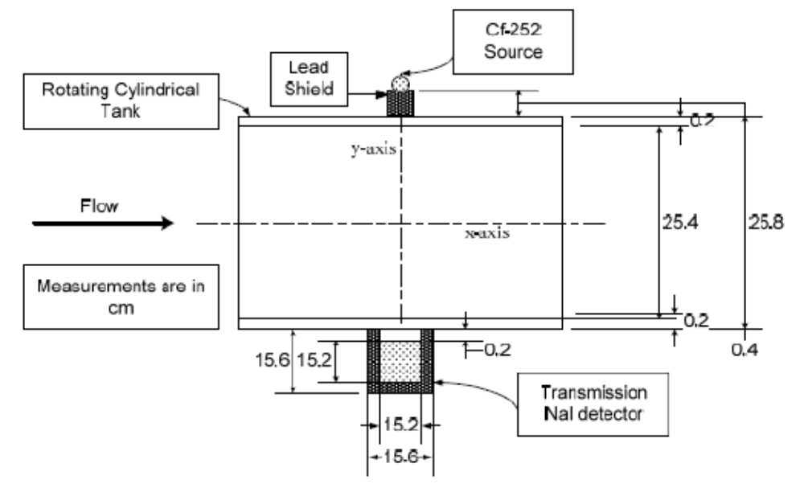
Results of the work showed that this approach would be accurate and feasible. A suggestion was made to include a Cs-137 source to also use gamma-ray densitometry for better sensitivity to the gas phase. The results, as well as other experiment-specific details, are shown later in this paper.
Work was continued on this design. With the exception of the addition of the Cs-137 source, the approach used by Wang et al. (2008) was identical to the one used in 2007. The system treated in 2008 is shown below in Figure XXX. Other experiment parameters are listed in Table XXX below for both the 2007 research and the 2008 research.
Figure XXX
Measurements are in cm
6 in x 6 in NaI detector
Lead shield
Cf-252 and Cs-137 Sources
0.5
0.5
25.4
10
0.2
0.2
5
Aluminum Cylindrical Tank
25

In the study at hand, an actual model of the system was built in an attempt validate this approach. For this reason, there was no iteration step in the MCLLS approach. In addition, a physical apparatus was designed for use of this measurement approach in oil production lines, applying the physics of this project to the in-situ problem at hand.
Certain changes had to be made to the set-up and materials used in previous studies in order to build an actual model. These changes include using acetic acid in place of the oil phase and air instead of methane for the gas phase. Reasons for the changes that were made are described later in the _______ section of this paper. Shown in Figure 3XXX below is the system that was built and treated in the study at hand. Table 2XXX below compares parameters that were used in this project as compared to the work done by Mutiso et al. (2007) and Wang et al. (2008).
Figure 3XXX
Get Vis-Ed or Cad drawing from Hester
Table 2XXX
 | 2007 | 2008 | Current Study
Elements Considered | H, C, O, Na, Cl, K, S, Ca, Mn | H, C, O, Na, Cl, K, Ca, Mg | H, C, O, Na, Cl, N
Chemical Formula of Oil | C₁₈H₃₈ | C₁₈H₃₈ | CH₃COOH
Density of Oil | 0.8 | 0.8 | 1.0567
Chemical Formula of Gas | CH₄ | CH₄ | Air
Density of Gas | 0.031 | 0.031 | 0.012
Density of Water | 1.025 | 1.025 | 1
Weight % of Salt (W) | 3 | 3.34 | 1.4778
Saltwater Density | - | 0.007595 W + 1.00000 | 1.009
Solution Density | 0.92 | 0.92 | 0.505
Phase Libraries | Oil, Water, Gas | Oil, Water, Gas, Salt | Oil, Water, Gas, Salt

It is of note that the elements used vary from year to year. Referring to Table 2XXX it is clear that from 2007 to 2008, sulfur was dropped completely due to difficulties with the code. This is explained in more detail later in this paper.
In conclusion, work has been performed by several groups at NC State CEAR in an effort to model bulk multiphase flow by PGNAA. It is the work of this senior design team to demonstrate the method of measurement used and present the design of the undersea apparatus that will make use of this method in an undersea system for the measurement of the in-situ phases of oil, gas, water, and salt.

METHOD AND PROCEDURE

Apparatus

The dilemma presented by the design of the apparatus and validation of the code package was generating a working physical model to accurately represent industrial apparatus. The industrial application will be associated with the (insert technical name here) pipe that draws the oil from the sea floor well up to the surface pumping station. In this pipe it is of interest to determine the contents of the pipe by volume fraction in order to economize the separation process. The in situ pipe is typically a stainless steel pipe of approximately 10-12 inches in diameter. The components of the pipe will be methane, saltwater and crude oil. The percent composition will be precisely unknown but within some approximate values and the concentration of the saltwater is another unknown to be solved. Given this problem, the experimental apparatus was designed, simulation flow components were gathered and data was collected such that the code could be validated under laboratory conditions. Going forward, the methods section will proceed with materials selection and description, then the source, detector and counting system will presented and finally, the procedure followed will be delineated for reproducibility.
Beginning with materials, the first objective was simulating the pipe with similar materials and dimensions. To this end, steel was selected, specifically 304 stainless steel. {need elemental distribution} Regrettably, steels in general, produce a negative impact on neutron economy. However, as this is a function of the iron content and given the corrosive nature of the components that would ultimately be placed within, stainless steel was chosen over the less expensive, but higher Fe content, carbon steel. Al was also considered for its cost and lack of neutron attenuation, but its structural instability at the dimensions in question made it infeasible. With material selection complete, the design of the canister had to be such that it was lidded to reduce evaporation and provide a method for constraining the ball screen during the four-phase runs. With all of the design criteria established the tank construction was commissioned. Two vendors were considered, the onsite precision machine shop and Stainless Steel Specialties, Inc. The two vendors submitted estimates of similar amounts, but the machine shop was not able to produce to the exact dimension specified but rather was using a piece of scrap of similar dimension. SSI for a nominally larger cost was able to produce a tank exactly as specified.
The next objective was to design a table such that modeling the table for the CEARCPG input was simplified. The primary concern was material for the table such that neutron economy was ensured and secondly, that if such material was available that it has the structural rigidity to maintain stability with the combination of filled tank, lead bricks and detector with shielding. The table’s necessity was to raise the experimental apparatus 3 feet above the floor to reduce the impact of background related to the structural materials of the building. The chosen design was simply a x-shaped base with a 24” x 24” top. The X was made by cutting a slot into two 24” x 36” panels. For stability with minimal cost, medium density fiberboard (MDF) was chosen. To improve the stability and maximize available surface area the base was set corner to corner relative to the top. With a known density the MDF could be modeled along with the other components. Ultimately, this level of detail was determine to be unnecessary and was not included in the input cards. { need picture with dimensions, table , layout, etc.}
With table and tank developed, radiation shielding was analyzed by Mr. Gerald Wicks and a team was assembled to build the shielding wall. Fortunately, the team expanded with the recruitment of volunteers as the ½ cinder blocks were brought from the building loading dock to the third floor lab. A total of blah cinderblocks along with a small number of paraffin blocks was used to provide the necessary shielding to us and to passers-by in the hallway and students that may be attending class opposite the lab. The combination of materials provided the necessary shielding from neutrons generated by the Californium. The {dimensions} wall surrounded the experiment on three sides and to a height of approximately 5 feet to ensure adequate coverage. The fourth side faced the reactor bay at a considerable elevation, so required no shielding.
With all of the structures in place for conduction of the experiment, the treatment of sources will be considered. Two sources have been used, Cf-252 and Cs-137. First will be the Cf-252 source as a neutron source. Californium is a man-made source that decays with a half-life of 2.64 years through spontaneous fission 3.1% of the time. Only a few grams have ever been produced. This level of decay produces 140 million neutrons per minute per microgram. The source size used was 2.2 micrograms. The source strength was producing excessive dead time in the detector and so had to be moved back from the tank and collimated to reduce the intensity. The acquisition of the source (i.e. vendors and costs) will be dealt with in the economics section. The sources were supported by several lead bricks to provide beta and gamma shielding from both sources and to insure that the sources were positioned at the mid-plane of the tank opposite the detector. The positions of the bricks are indicated in the figure below

insert picture

The second source was the Cs-137. The Cs serves two functions in the system, first, as a means to calibrate the electronics and secondly, as a densitometric source to enable the distinction between the methane gas and the liquid phase oil. On the calibration end Cs-137 has a characterist gamma emission of 662 keV of significant intensity. Utilizing this peak the MCA was calibrated to provide an energy correlation for the channel numbers output from the MCA. The presence of the gamma source also enabled the adjustment of the amplifier gain to produce an energy spread up to approximately 11 MeV. As the energy spectrum of interest was so broad the 662 peak provided a reasonable cutoff energy for utilizing the lower level cutoff on the MCA to eliminate excessive noise that was contributing to the detector dead time. The second function of the Cs was as a densitometer. This aspect was essential in this experimental case as the methane was simulated by air, however it did provide a level of consistency in experimental results that will be practical in the evolution of this PGNAA work. In the in situ case the Cs peak intensity would be correlated to the density variations in the flow and would provide a means of calculation of the methane fraction, given the elemental similarities between the oil and methane. Because of the presence of these sources a dosimeter was required when any team member entered the room. Additionally, for any source handling, Mr. Wicks was called in and the shield wall was the boundary of the work area. The team was restricted to working outside the boundary and could only manipulate the tank contents with sources removed. This did provide an occasional scheduling conflict but these are overcome each in turn with flexibility and planning.
The detector and its accompanying electronics will complete the apparatus section. The detector itself is a 6” x 6” NaI scintillator. It weighs approximately 20 pounds and has a cylindrical lead shield around the crystal chamber to ensure that only those gammas from the tank are included in the measurement. When a gamma ray enters the detector chamber it is incident on the NaI crystal, the crystal is excited, and emits a gamma in the visible light spectrum which enters the photomultiplier (PM) tube generating a pulse that is recorded as a count on a channel. The scintillator is only the first component of the electronics. The photomultiplier tube is a necessary intermediate step to convert the light emitted from the scintillator crystal into signal for the MCA. The electronics continues with an amplifier, high voltage power supply and finally the MCA which provides the ability to put the signals received from the PM tube into slots or channels which are only a relative distribution until calibration at which point there is an energy to channel correlation. {need names of these things} The MCA card was part of a PC where the data spectrum could be view and then saved to a disk and transferred. It was in the PC’s Genie program that we were able to adjust the lower level settings to reduces noise and dead time as mentioned earlier.
With all of the equipment in place the lab was set up and counting began. The tank was positioned along with the lead and detector in place and background measurements were taken. The counting was conducted over a 24 hour time period. This was done to ensure a sufficient number of counts to reduce uncertainty in composition calculation later. The initial counting steps included some adjustments to the electronics which would remain the settings until the counting was completed for all phase runs. It was necessary to capture an energy spectrum that contained energies in the range up to 11 MeV. With only 2048 channels in the MCA this required that there not be a 1:1 energy-channel correlation. To meet this objective the MCA was calibrated using two sources, Co-60 and Cs-137, these two sources produce a total of three very strong gamma energy peaks. They are 1172 keV and 1332 keV for Cobalt and 662 keV for the Cesium. For the purpose of calibration these two sources were placed directly in front of the detector for a time period sufficient to generate the three very distinct peaks. This was on the order of 30 seconds. Part of the functionality of the MCA, is that with the peaks displayed, the channels representing the centerlines of these peaks could be assigned to the known energies of the gammas there. With this step completed the amplifier had to be adjusted to get the breadth of energy spectrum required. The gain on an amplifier is used to enhance the multiplication effect in the PM tube such that scintillation reactions that result in gammas, perhaps of a lower energy that might otherwise be missed, are multiplied so that they produce counts as well. This is a uniform multiplication process such that the entire counted spectrum is broadened. The gain was set to {need values}. This produced a spectrum of energies zero to 11 MeV. It was at this point that there was some duplication of counting sequences and some learning curve to overcome. The background count was taken with all sources removed, but with the tank and shielding in place. The next step was a two phase salt and water combination to note the spectrum associated with only those two components in place so that particular elemental effects on the spectrum could be observed. This progressive phase addition was believed to be an effective method to ensure accuracy and be able to provide some baseline to return to if at some phase addition the spectrum results did not appear as expected based on composition and needed to be reexamined. This salt-water run was successful, so the acetic acid was placed in solution in the tank, mixed thoroughly and an additional run was performed. With these two sets of results in hand it was noted that the detector dead time was excessive, ≈75%. The dead time represents the fraction of the counting time that the detector is essentially blind to interactions. It is the result of a very rapid succession of interactions such that the individual interactions cannot be distinguished. The rapid pulse succession is referred to as pulse pileup. {picture of pileup}. After the completion of these two runs it was determined that another feature of the MCA needed to be used, namely the window controls. The dead time was attributed to the noise at the lower end of the spectrum, and with the understanding that the lower end (< 400 keV) was not significant to the results, the lower level window was set to block those counts and the dead time was reduced to ≈8%. This adjustment required some duplication but not returning to the two phase run but only performing the three phase experiment again. With the new set of electronics settings in place the three phase run was redone. After each experimental run was performed, the same phase scenario was presented to the modeling code CEAR-CPG for spectrum comparison. This was only for comparison purposes to ensure that the experimental data correlated well with the theoretical. {should I say this part} The next phase (ha ha ) in the experiment was to add the gas phase. In order to do this the three phase solution was removed and placed in a storage container. At this point the opportunity to recount the background was taken. The tank was cleaned and replaced and another background count was taken with the current MCA settings for consistency. This complete, the four phase experimental set up was begun. The gas phase was to be simulated by table tennis {this might be more sophisticated} balls. A total of 522 were use to fill the tank fully and uniformly, a screen was secured to the top of tank to secure the balls from floating. The acetic acid solution was then replaced by pouring it through the screen. {will Andrew be talking about density calculations, concentrations, etc} The lid was repositioned to secure the screen and counting began again. This represented the final experimental activity. The subsequent work to be done was with modeling in CEAR-CPG and finally, composition verification with MCLLS. {do I stop here or continue with code process}

Phase components

The main objective of the experiment is to construct a prototype, or as closely as possible, to model how prompt gamma neutron activation analysis could correctly determine the components of a four phase system. The materials for the inside of the container were chosen to “imitate” what one might find in the production fluid of an offshore oil drilling operation. The four phases consist of water, salt, oil, and gas. Due to design limitations, the mixture itself had to be static since the container and experimental set up had no moving parts (pumps, etc.) in order to continuously mix the fluid.
For the salt phase, simple addition of sodium chloride sufficed to give the water a brinish quality. The density of the resulting saline solution was calculated using the weight percent of the salt added from the Handbook of Chemical Engineering (Don’t remember who Gardner’s book is by). The data listed in the handbook was plotted (Figure 2) and a line of best fit used to determine solution density for the weight percent of sodium chloride we used.
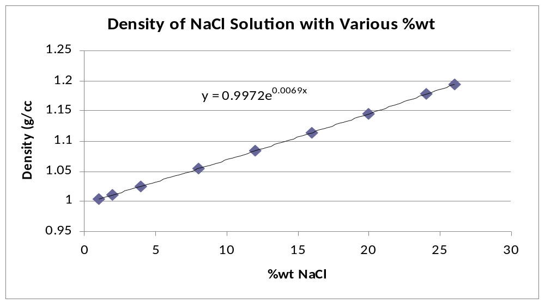
Figure XXX: Density of NaCl-water solution as a function of weight percent of NaCl

The calculations for our saline mixture can be found in Table 1 as follows.

Salt Water
Volume of Water (L) | 22.8
Mols of Water | 410400
Mass of water (kg) | 22.8
Mass of NaCl added (kg) | 0.342
Mols of NaCl | 14.86633341
Concentration (kg/L) | 0.015
Density of Water (kg/L) | 1
Density of NaCl, solid (kg/L) | 2.16
Density of Solution (kg/L) | 1.007420514
Total Mass (kg) | 23.142
Weight Fraction of Water | 98.5222%
Weight Fraction of NaCl | 1.4778%

Table XXX:

It therefore became a challenge to form a homogeneous mixture of the aforementioned phases, specifically oil and salt water. Instead of using crude oil, it was devised to use another organic compound that would be miscible in water. Carboxylic acids were determined to be the most favorable since their strong polar group would allow for hydrogen bonding with the water.

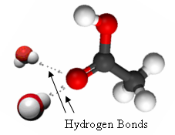

Figure XXX: The interaction of water with the carboxylic functional group of acetic acid

At the same time, the carbon in the alkane chain part of the molecule could be activated by neutrons to determine whether or not PGNAA was feasible for multiphase flow measurement in oil rigs. Due to cost constraints, the majority of our solution was distilled water. Therefore, we determined that acetic acid would be the best candidate for being retained in solution. The salt was not added in excess in order to prevent the acetic acid from “salting out” of solution. This would occur if the solution became too ionic in nature by having a large concentration of salt. The overly ionic character of the solution would push the acetic acid into an organic layer since the hydrocarbon tail’s non-polarity would override the polar hydrogen bonding. The resulting solution density and weight percents of the components were calculated using values in Table XXX. Later, it was decided that more salt could be added to the solution to help increase the number of counts from sodium and chlorine. The adjustments are shown in Table 3.

Salt Water With Acetic Acid
Volume of Salft Solution Removed (L) | 2.5
Total Mass of Solution Removed (kg) | 2.518551284
Mass of Salt Solution Remaining (kg) | 20.62344872
Mass of Water Removed (kg) | 2.481331314
Mass of Salt Removed (kg) | 0.03721997
Mass of Salt Remaining in Solution (kg) | 0.30478003
Mass of Water Remaining (kg) | 20.31866869
Volume of Water Remaining (L) | 20.31866869
Volume of Acetic Acid Added (L) | 2
Density of Acetic Acid (kg/L) | 1.0567
Mass of Acetic Acid Added (kg) | 2.1134
Total Mass of New Solution (kg) | 22.73684872
Weight Fraction of Water | 89.364%
Weight Fraction of Acetic Acid | 9.295%
Weight Fraction of Salt | 1.340%
Density of New Solution (kg/L) | 1.012001063

Table XXX

Adjusted Salt Water with Acetic Acid
Mass of Salt Added (kg) | 0.15
Total Mass of Salt in Solution (kg) | 0.45478003
Volume of Water in Solution (L) | 20.31866869
Density of New Salt Water (kg/L) | 1.010966623
Mass of Acetic Acid in Solution (kg) | 2.1134
Total Mass of Solution (kg) | 22.88684872
Weight Fraction of Water | 88.78%
Weight Fraction of Acetic Acid | 9.23%
Weight Fraction of Salt | 1.99%
Density of New Solution (kg/L) | 1.0151897

Table XXX

The gas phase of the mixture consisted of atmospheric air encapsulated in table tennis balls. The tank was filled with the balls and then a wire mesh secured over the top. The aqueous salt and acetic acid were then poured into the tank to fill all remaining space. It was decided that this was the best way to have a homogenous four-phase mixture. The table tennis balls are made of celluloid, a polymer made from cellulose, and its composition was determined with the help of the Kirk-Othmer Encyclopedia of Chemical Technology and Ullmann’s Encyclopedia of Industrial Chemistry. The composition of the plastic is listed in Table XXX4.

Plastic Composition
Dinitrocellulose | 72.50%
Camphor | 27.50%
Camphor weight (amu) | 152.25
wt%C | 0.788834154
wt%O | 0.105024631
wt%H | 0.106141215
Dinitrocellulose weight per glucose unit(amu) | 252.07
wt%C | 0.285872972
wt%O | 0.570912842
wt%H | 0.032054588
wt%N | 0.111159599
Total Elemental Composition
wt% C | 0.424187297
wt% O | 0.442793584
wt% H | 0.05242841
wt% N | 0.080590709
Table XXX4

The final “homogeneous” four phase solution calculations can now be made. The results are given in Table XXX5.

Four - phase mixture
Amount of solution (L) | 11.5
Number of ping pong balls added | 522
Volume of air inside one ball (m^3) | 2.87163E-05
Density of Atmospheric Air (kg/m^3) | 1.168
Weight of Ping Pong ball (kg) | 0.002521
Weight of Air inside ball (kg) | 3.35407E-05
Weight of Plastic of one ball (kg) | 0.002487459
Total Weight of Air in Tank (kg) | 0.017508242
Total Weight of Plastic in Tank (kg) | 1.298453758
Total Weight of Salt in Tank (kg) | 0.231985281
Total Weight of Water in Tank (kg) | 10.36464169
Total Weight of Acetic Acid in Tank (kg) | 1.078054576
Total Mass in Tank (kg) | 12.99064355
Weight Fraction of Water | 79.79%
Weight Fraction of Acetic Acid | 8.30%
Weight Fraction of Salt | 1.79%
Weight Fraction of Plastic | 10.00%
Weight Fraction of Air | 0.13%
Density of Homogeneous Solution (kg/L) | 0.504561531

Table XXX5

CEARCPG

Inputs and Outputs

The inputs into CEARCPG-MCNP were comprised of input cards. Below is a modified input file for the four phase run. All input files, unmodified, will be attached to the appendix as well. The following input file was modified so that it could be discussed. As comment signifiers seem to result in fatal errors, we could not comment the code. The only exception is the first line, which is the title and date of the code, with c being the comment signifier.
Printed in figure XXX below is the cell card; it is part of the geometry input for MCNP. The cells are defined as follows. The first number is the cell number. The cell numbers are not in order because they are grouped by object that they represent. For instance, cell number 1, 11, and 12 define the tank. Cell 2 defines the sample. Cell 3 is the sodium iodide is the detector. Cell 4 is the borated polyethelene. Cell 16, 17 and 18 is the lead shielding. Cells 5, 6, 7, 13, 14, 20, , 8, 15, 19, 9, 21, and 22 define the rest of the universe. Lastly, cell 10 is the lead around the sodium iodide detector. The second number signifies the materials, and corresponds to the material card below. The third number is the density of the material (the negative sign signifies that the density is in g/cm^3). Therest of the numbers are the surfaces that define that cell.

Figure XXX CEARCPG Input file – Cell card (Final: 04/09/08)

1 | 5 | -7.93 | 1 | -2 | 4 | -5
11 | 5 | -7.93 | -2 | 3 | -4
12 | 5 | -7.93 | -2 | 5 | -6
2 | 7 | -0.93 | -1 | 4 | -5
3 | 6 | -3.667 | -7 | 8 | -9
4 | 8 | -0.955 | 17 | -11 | -14 | 3 | 18 | 13 | -12
16 | 4 | -11.34 | 16 | -19 | 3 | -14 | 13 | -12
17 | 4 | -11.34 | 19 | -20 | 3 | -14 | 21 | 13 | -12
18 | 4 | -11.34 | 20 | -17 | 3 | -14 | 13 | -12
5 | 1 | -0.0012 | -8
6 | 1 | -0.0012 | 11
7 | 1 | -0.0012 | 7 | -11 | -3
13 | 1 | -0.0012 | 7 | -10 | 6
14 | 1 | -0.0012 | 7 | -10 | 3 | -6 | 2
20 | 1 | -0.0012 | 10 | -16 | 3
8 | 1 | -0.0012 | 16 | -11 | 14
15 | 1 | -0.0012 | 16 | -11 | 12 | -14 | 3
19 | 1 | -0.0012 | 16 | -11 | -13 | -14 | 3
9 | 1 | -0.0012 | 8 | -7 | 15
10 | 4 | -11.34 | 8 | -7 | -15 | 9
21 | 1 | -0.0012 | -18 | 17 | -11
22 | 1 | -0.0012 | -21 | 19 | -20
Shown in figure XXX below is the surface card; it is also part of the geometry input for MCNP. Since the surfaces can correspond to multiple cells, there was no order except the order in which the cell was defined. The first number is the surface number, (when in the cell card, negative number refers to the side of the axis, or the inside of the cylinder.) The next variable defines the kind of plane, i.e. the flat plane and the axis it intersects, or the cylindrical plane, and the axis it revolves around. The slashes just indicate an offset from the zero axis. Lastly, the numbers define the position of the surfaces.

Figure XXX CEARCPG Input file – Surface Card (Final: 04/09/08
1 | cz | 12.7
2 | cz | 12.86002
3 | pz | 0
4 | pz | 0.16002
5 | pz | 50.96002
6 | pz | 51.12004
7 | px | -12.86002
8 | px | -29.3102
9 | c/x | 0 | 25.4 | 7.62
10 | px | 12.86002
11 | px | 42.07002
12 | py | 5.08
13 | py | -5.08
14 | pz | 30.48
15 | c/x | 0 | 25.4 | 10.16
16 | px | 16.67002
17 | px | 36.99002
18 | c/x | 0 | 25.4 | 0.635
19 | px | 21.75002
20 | px | 31.91002
21 | c/x | 0 | 25.4 | 1.27

Shown in figure XXX is the material card. The numbers with m’s in front of them dictates the material number. While not all the materials were used in this output deck, they were retained so that the output decks would be consistent. The materials are air, water, wood, lead, SS – 304, Sodium Iodide, sample material (in this case, water, acetic acid, salt and air, with trace amounts of celluloid nitrite), and borated polyethylene. The second number is the material and the isotope. (The ending of 000 refers to natural isotopic). And the last number refers to weight percents of the material (a non negative number signifies atom percent).

Figure XXX CEARCPG Input file – Material Card (Final: 04/09/08

m1 | 07014 | -0.767
 | 08016 | -0.233
m2 | 01001 | -0.1119
 | 08016 | -0.8881
m3 | 01001 | -0.06217
 | 08016 | -0.49334
 | 06012 | -0.44446
m4 | 82000 | -1
m5 | 28000 | -0.105
 | 26000 | -0.67498
 | 25000 | -0.02
 | 14000 | -0.0075
 | 24050 | -0.19
 | 07014 | -0.001
 | 06012 | -0.0008
 | 15000 | -0.00045
m6 | 11023 | -0.14341
 | 56138 | -0.85659
m7 | 01001 | -0.10009
 | 08016 | -0.79737
 | 06012 | -0.07559
 | 11023 | -0.00703
 | 17035 | -0.01083
 | 07014 | -0.00909
m8 | 05010 | -0.05
 | 06012 | -0.81347
 | 01001 | -0.13653

The rest of the input deck defines other information, such as the source – the position, the strength, the material, the position of the sample, the detector specs, and the number of iterations the code is going to be run. It is shown in figure XXX below. Normally, the code is run for 10 million iterations, which equates to about 48 hours of run time on the cluster.

Figure XXX CEARCPG Input file – Balance of Input Deck (Final: 04/09/08)

imp 1 1 1 1 1 1 1 1 1 1 1 1 1 1 1 1 1 1 1 1 1 1
sdef cf x=42.0 y=0 z=25.4 icel=21
nps 10000000
number_detector 2
detector -12.86002 0 25.40 7.62 15.24 3
-12.86002 0 25.40 7.62 15.24 3
wcut 1d-4 1d-3 1d-5 1d-6 0.02
sample 2
spect 2048 512 0 0 0.0055575 18000 0.0055575 0.02223
detcoin 1 ( 3 : 3 )

Vised, an MCNP related code, outputs images to help with visualizing the geometry and to help with debugging any problems with geometry. Following are two images representing the final bench-top apparatus geometry. Included are a cross-section of the apparatus along the xz plane at y = 0cm, and a cross-section along the xy plane at z = 25.4cm:

Figure XXX Geometry of CEARCPG Input File (Final: 04/09/08)
Side View
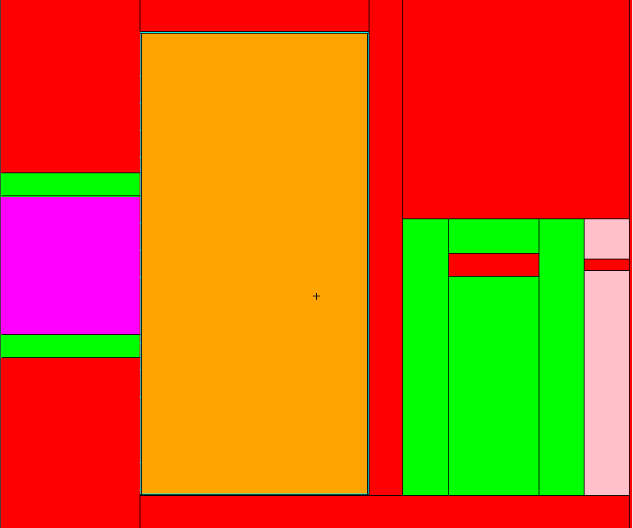

Overhead View
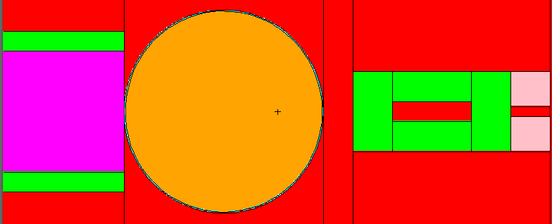
The colors in the figure XXX above represent different materials. They are:
        - Red: Air
        - Pink: Borated Polyethylene
        - Magenta: Detector
        - Orange: Contents of Tank (variable; dependent on run)
        - Green: Lead
        - Teal: Stainless Steel

The following figure details the logic flow chart of the code:

Figure XXX Flowchart of CEARCPG Logic (Final: 04/09/08) (CEARCPG Manual)
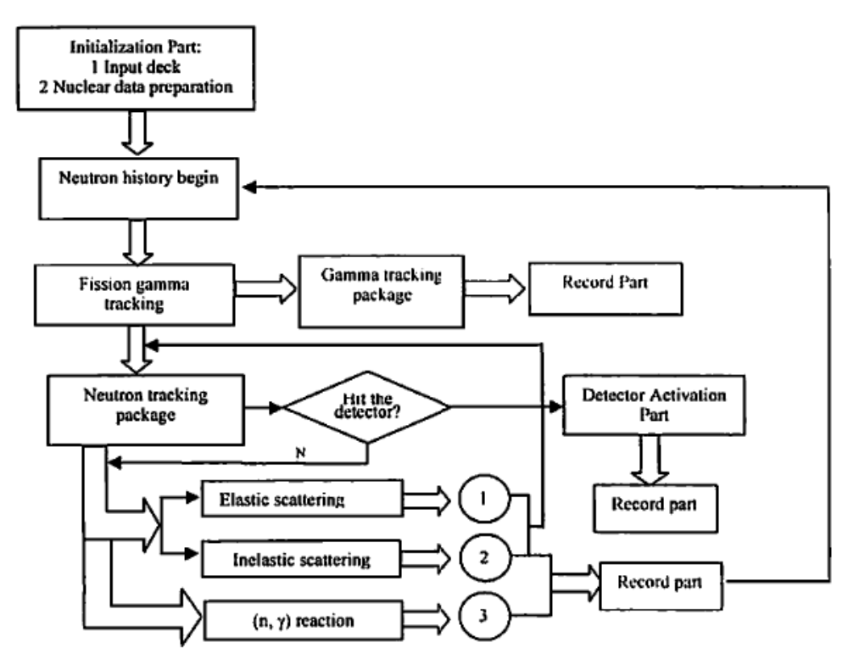
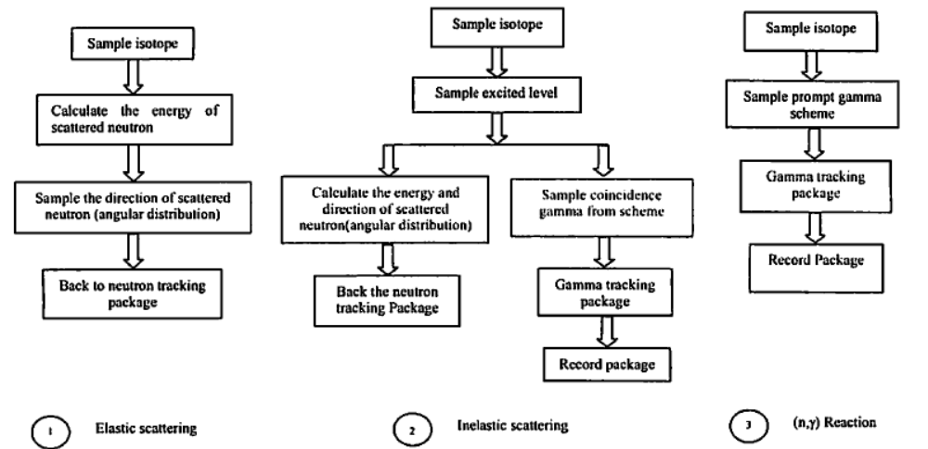

Given the input, the code outputs several output files. In each output file, there are 3 columns of data: the channels, the corresponding energy levels, and the counts associated with each energy level.

Assumptions and Limitations

The wooden table and detector stand were not modeled. It was assumed that the effects of the wood on the counts would be relatively negligible, due to it not being between the source and the detector, and probability of a prompt gamma reaction that reaches the detector is relatively low (based on geometry). In removing the wooden elements from the code, we were able to reduce the number of materials in the card, as well as simplifying the input deck.
In addition, we assumed that for the four phase run, that the mixture is homogenous. This is just to simplify the calculations as well as the modeling, in the interest of time.
Also, due to the fact that MCNP 4 was used, the libraries are not as updated. In addition, upon running the code, we have found that there were several elements that had incorrect/incomplete libraries. Though most of the elements that were removed were minor, such as that of sulfur in the stainless steel, what could cause the bigger problems was not being able to use a natural isotopic abundance for several elements. For example, all hydrogen was assumed to be protium, and all Chlorine was assumed to be Cl³⁵. The elements which required this process were assumed to take the form of the largest abundance isotope, regardless of how much the natural abundance of the rest of the isotopes of that element were. Though, the weight percents of these isotopes/elements that were neglected were each less (CHECK THIS… I DON’T KNOW FOR SURE) than 2 wt% of the total apparatus, so it should not affect the spectrum by much. The isotope and elemental make up of the sample, however, were correct for the most part.

Linear Least Squares Code

The linear least squares code only matches the experimental data to a proportion of the phase libraries. Therefore, any peak in count rate in the experimental data that is not found in an elemental library causes error in the linear least squares code. Some of these effects can be countered by taking an original background count and using this as a phase library. This also provides a quick check of the results, since the proportion to the data should be close to one. If this is not the case, there is a problem in the analysis of the data.
If there are any differences between channel number and energy between the experimental data and the phase libraries, the gain shift program is utilized. With this, any change to the experimental data must also be done to the background. This new background is then used as the new background library for analysis with the shifted data.

RESULTS

            - Three-phase Case

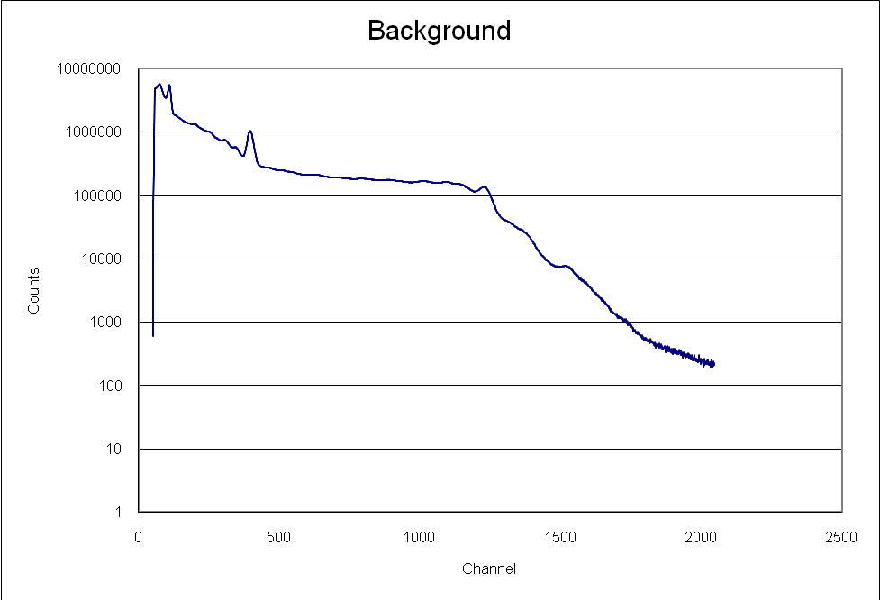

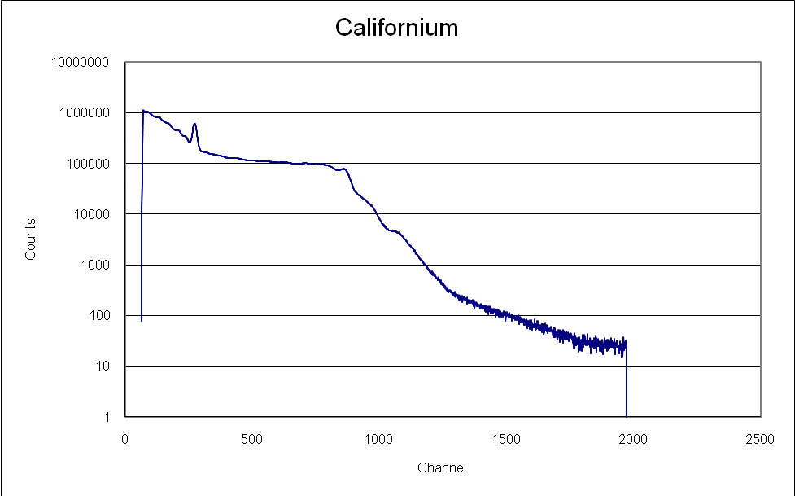

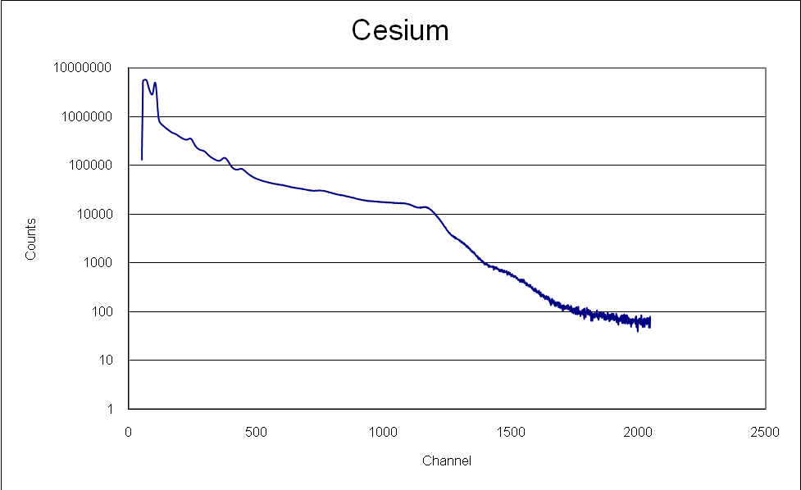

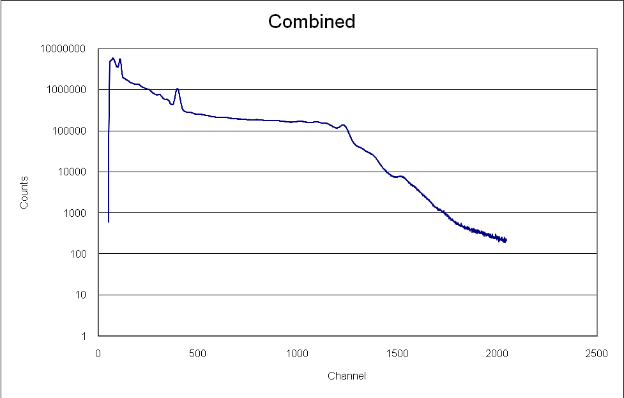

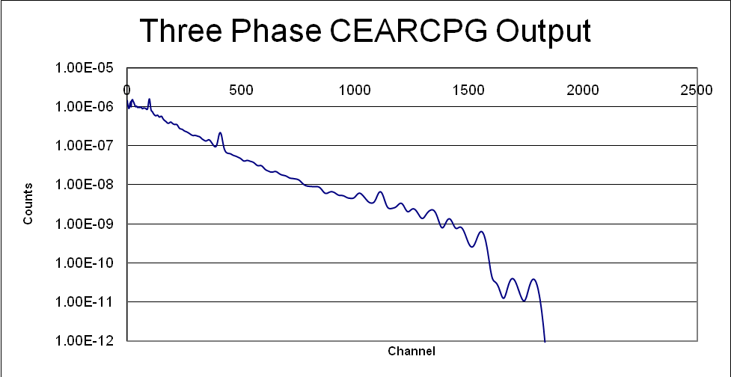

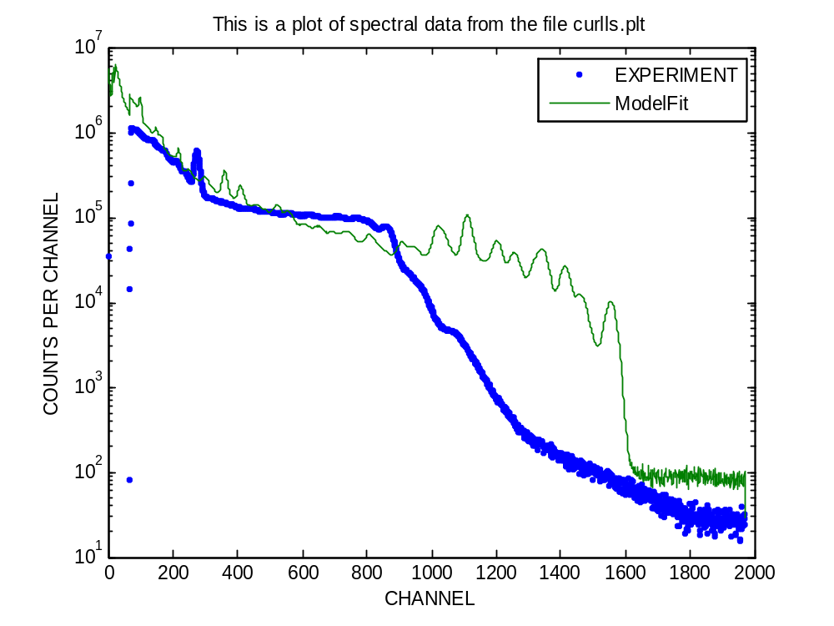
With salt
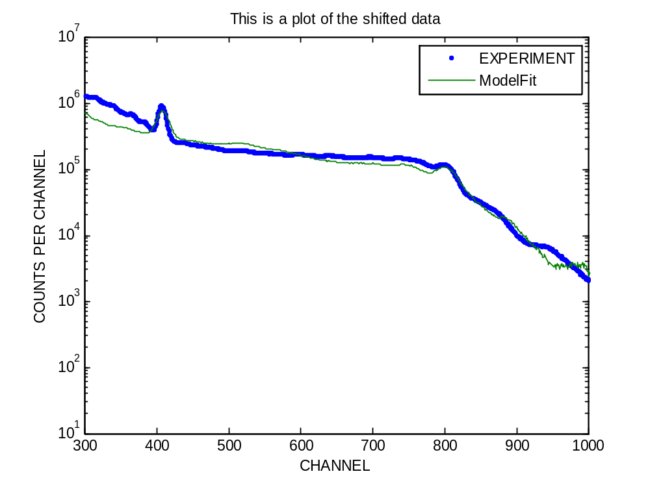
Without Salt+gain shift
Phase | Weight Percentage (LLS) | Error (%) | Weight Percentage Actual
Water | 84.05% | 0.2975% | 88.78%
Acetic Acid | 15.95% | 0.1786% | 9.23%
Background | 0.68 | 0.0412% | 1

            - Four-phase Case
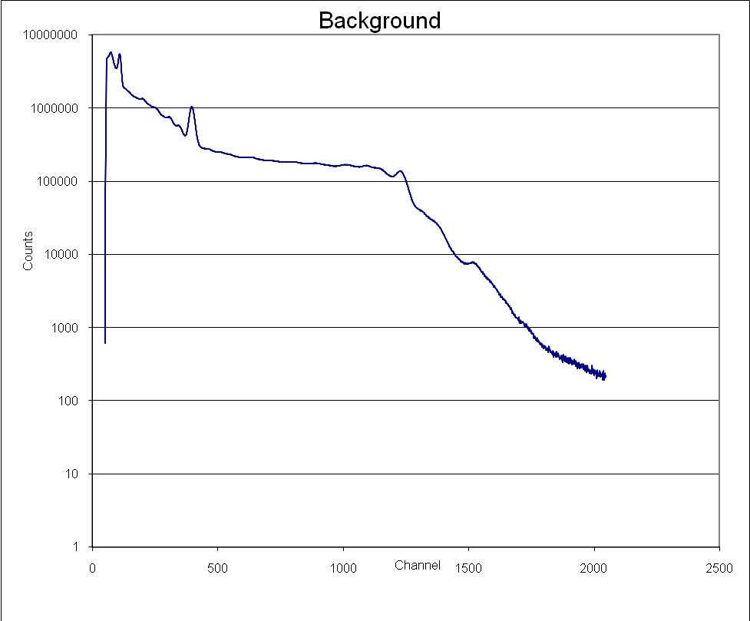
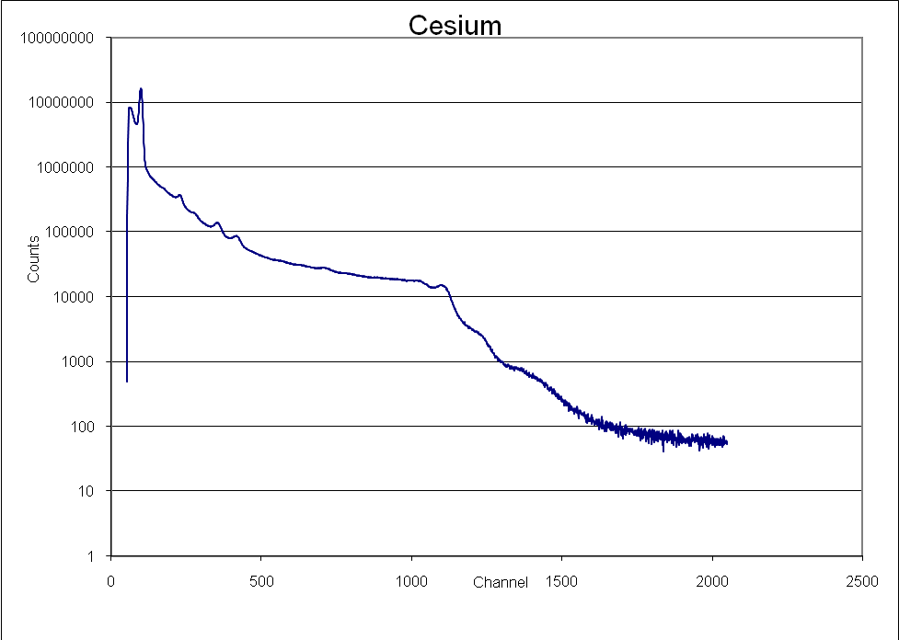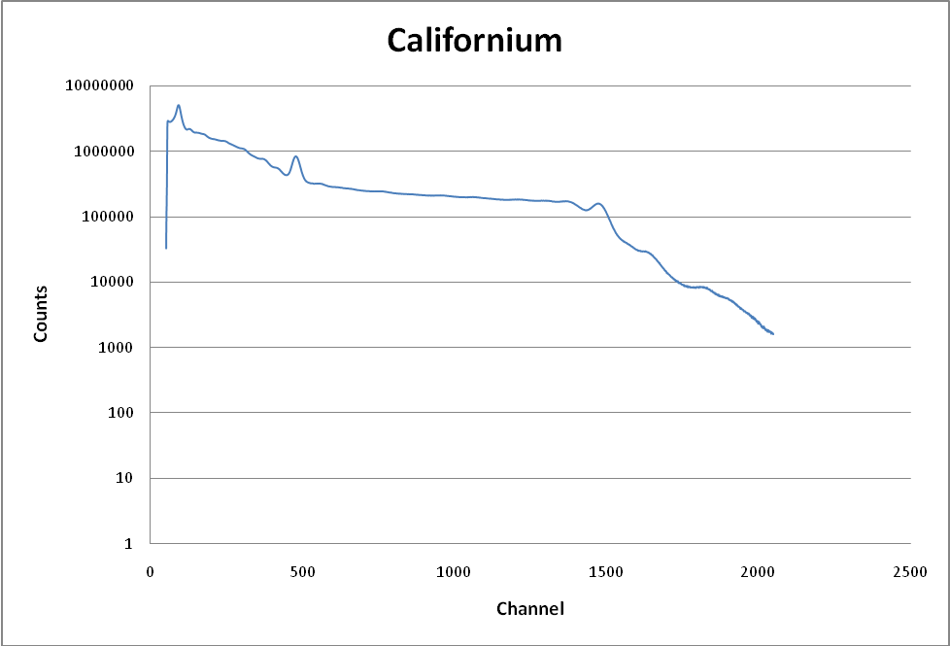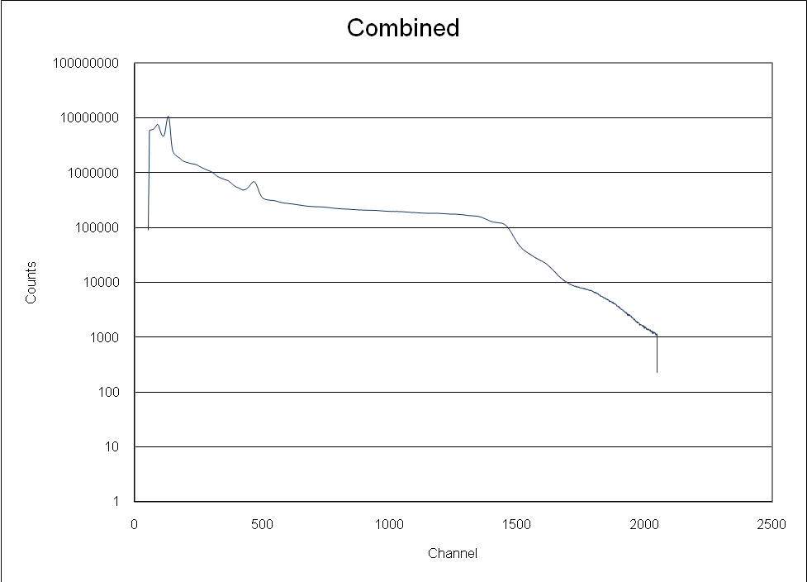

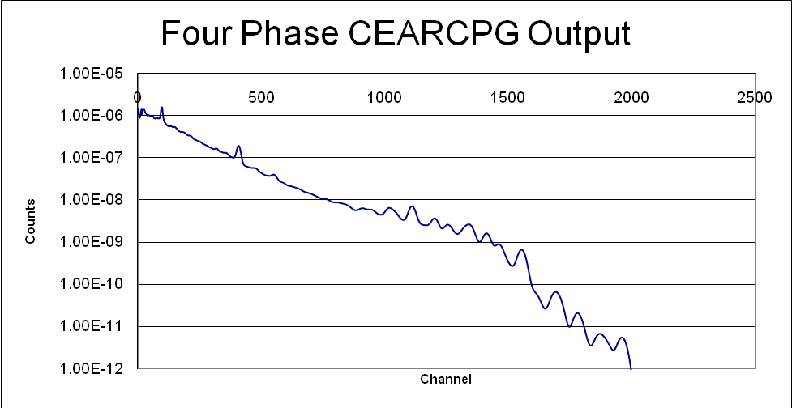

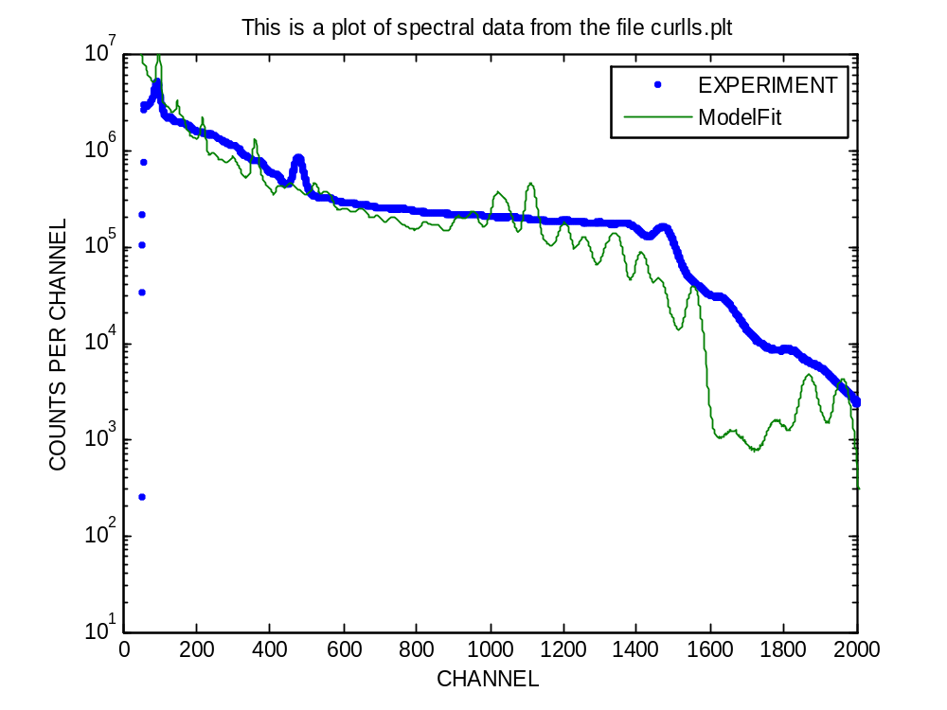
With salt original
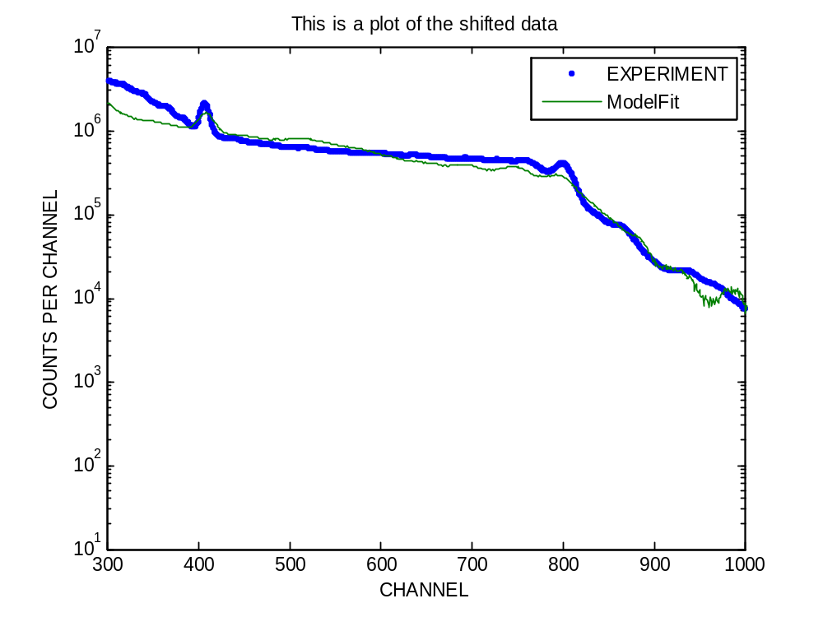
Without salt+gain shift
Phase | Weight Percentage (LLS) | Error (%) | Weight Percentage Actual
Water | 93.27% | 0.3043% | 79.79%
Acetic Acid | 5.80% | 0.3184% | 8.30%
Air | 0.95% | 0.3329% | 0.13%
Background | 2.20 | 0.0448% | 1

ON-LINE APPLICATION OF PGNAA

Introduction
In an interest to provide a useful connection between the results of the bench-top apparatus design study and the nature of the CEARCPG and CEARLLS codes, a multiphase flow analyzer has been designed that implements both PGNAA and gamma ray densitometry.
The design of this PGNAA Flow Analyzer reflects many features of the bench top system, and is fully encased in pressure-resistant stainless steel that may be welded between two joints in a section of underwater pipeline. The Flow Analyzer will consist of a central oil flow conduit, completion fluid conduits, a replaceable source plug, and a serviceable NaI detector and electrical equipment. Also considered within this design is the preparation of software required for operation of the analyzer at the surface.

Product Specifications
In the past thirty years, PGNAA has become an increasingly popular method for the quantification of material compositions in industrial environments. It has moved past the static realm and been adapted for online processes such as determining moisture and ash content of coal (Cutmore et. al., 1993) and industrial waste process detection (Holmes and Zoller, 1992). In this section of he study, a system has been developed for the analysis of production flow on an offshore oil drilling platform prior to its reception above the surface of the water.
Although there are many techniques already available to the petroleum industry, such as gamma transmission density gauges, the PGNAA approach couples this technology with the ability to also determine the salinity of the aqueous phase being transported along with the crude and gas phases. Also, the use of PGNAA in a multiphase flow meter can reduce the dependence on traditional methods of flow measurement, which require large separators and long periods of time to yield results (NFOGM, 2005).
A basic introduction to the anatomy of an oil pipeline is presented to help motivate and illustrate specific features of the PGNAA Flow Analyzer. The outermost layer of an oil pipeline is a protective, pressure-resistant steel casing that provides a supportive connection line between the platform and oil reservoir. It ranges in diameter from 4.5 to 36 inches, with the most common being from 5.5 to 13.75 inches (Hyne, 2001) with wall thicknesses ranging from 0.2 inches to 0.81 inches (Lyons & Plisga, 2005). The oil pipeline itself is composed of American Petroleum Institute (API) grade steel pipe that runs inside of the casing, forming an annulus. The oil pipeline is usually 1.25 to 4.25 inches in diameter (Hyne) with wall thicknesses increasing from 0.11 inches to 0.63 inches with increasing pipe diameter (Lyons & Plisga). After the annulus has been created, it is filled with a completion fluid that usually consists of treated water or diesel oil (Hyne). Water-based fluids can be seawater, brine from the reservoir or a prepared salt solution to obtain a certain pH or to scavenge unwanted chemicals. Oil-based fluids include mineral oil, crude, diesel, or water in oil emulsions (Lyons & Plisga).
The proposed design will incorporate a specialized piece of well casing that has been modified to hold the source container and the detector (Figure XXX) with a given width that will accommodate the selected tubing size.
Sources
Detector
Cf-252
Cs-137
Detector
Casing
Tubing
To MCA
Figure XXX. Geometry of proposed PGNAA Flow Analyzer within oil pipeline.

The source container and detector can be directly welded to the casing to ensure good alignment and positioning flush against the inner oil tubing. It would not be feasible to attach the sources and detector to the outside of the casing due to the fact that the neutrons would be attenuated and reflected by the completion fluid housed in the annulus. Neither would it be possible to have the sources and detector completely housed inside the annulus without breaching the casing due to size constraints. Placing the detector and sources flush against the tubing prevents gamma attenuation within the casing, and allows for an increased number of counts to be recorded.
Once the modified casing has been assembled, it can be shipped to the oil rig that is under construction in order to be put in the desired elevation along the casing string. Each design will need to be custom welded to the specifications for that particular drilling operation due to the different combination of casing and tubing diameters.
The sources to be utilized in the Flow Analyzer apparatus will be the same as used in the bench top apparatus. A 2 μg Cf-252 will serve as the neutron source for generation of prompt gammas. This source strength maintains reasonable cost and is similar to that utilized in other industrial applications, such as the analysis of cement raw materials (Olivera et. al., 1993).
Additionally, a 65 mCi Cs-137 will be used to enable gamma ray densitometry. The presence of the Cs-137 will be of special importance in the in situ study compared with the stationary laboratory apparatus because of the presence of methane gas. The following theory of the calculation of gas volume fraction in a mixture of oil, water, and gas is presented by Tjugum et. al. (2002):
Calibration measurements of transmitted intensity are assumed to exist for pipes of diameter filled with water (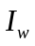), oil (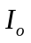), and gas (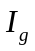), as follows:
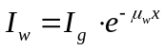
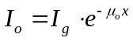

Then, given the amount of water cut in the tube ( 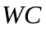), the transmitted intensity of the four-phase mixture (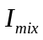) may be computed as follows:
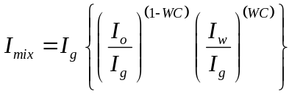

from which the following equation for gas volume fraction may be derived:
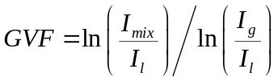

The presence of the Cs-137 source will generate the transmission data necessary for determination of the gas volume fraction as demonstrated above. This will be useful in the program’s final analysis of the flow composition.
Neutrons emitted by the Cf-252 source will generate prompt gamma-rays by neutron capture, elastic scattering and inelastic scattering, of which capture is the most important. Figure XXX below indicates the radiative capture cross section of the main elements encountered within the production flow.
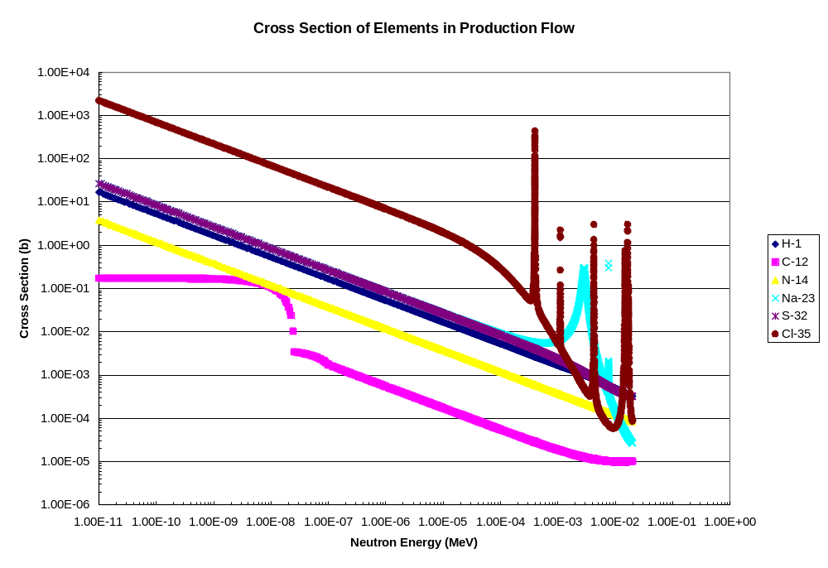
Figure XXX: Neutron capture cross sections for elements present in production flow.

Figure XXX above illustrates the low capture cross-section of carbon, indicating the importance of thermalizing the Cf-252 neutrons, which are born with average energy of 2.14 MeV, prior to their interactions with the flow stream. The significant hydrogen content of the completion fluid and the oil flow stream should provide sufficient thermalization of the neutrons so that they may be readily captured.
The sources will be housed in a cylindrical container as shown in Figure XXX. Shielding calculations were based on the United States Federal Occupational Dose Limits (See Appendix AAA for shielding calculations worksheet). The lead, polyethylene, and steel shielding will provide a dose rate of 0.136 mSv/hr from Cf-252 neutrons at 0.4 m from the sources. Based on the principles of ALARA radiation management, this was determined to be an acceptable dose rate for a single radiological worker during the short work period spanning the removal of the apparatus from its protective shipping container (sufficient to maintain the dose rate at or below 0.025 mSv/hr) to its submersion in water. Once submerged, the seawater will scavenge any extraneous neutrons and gamma rays.
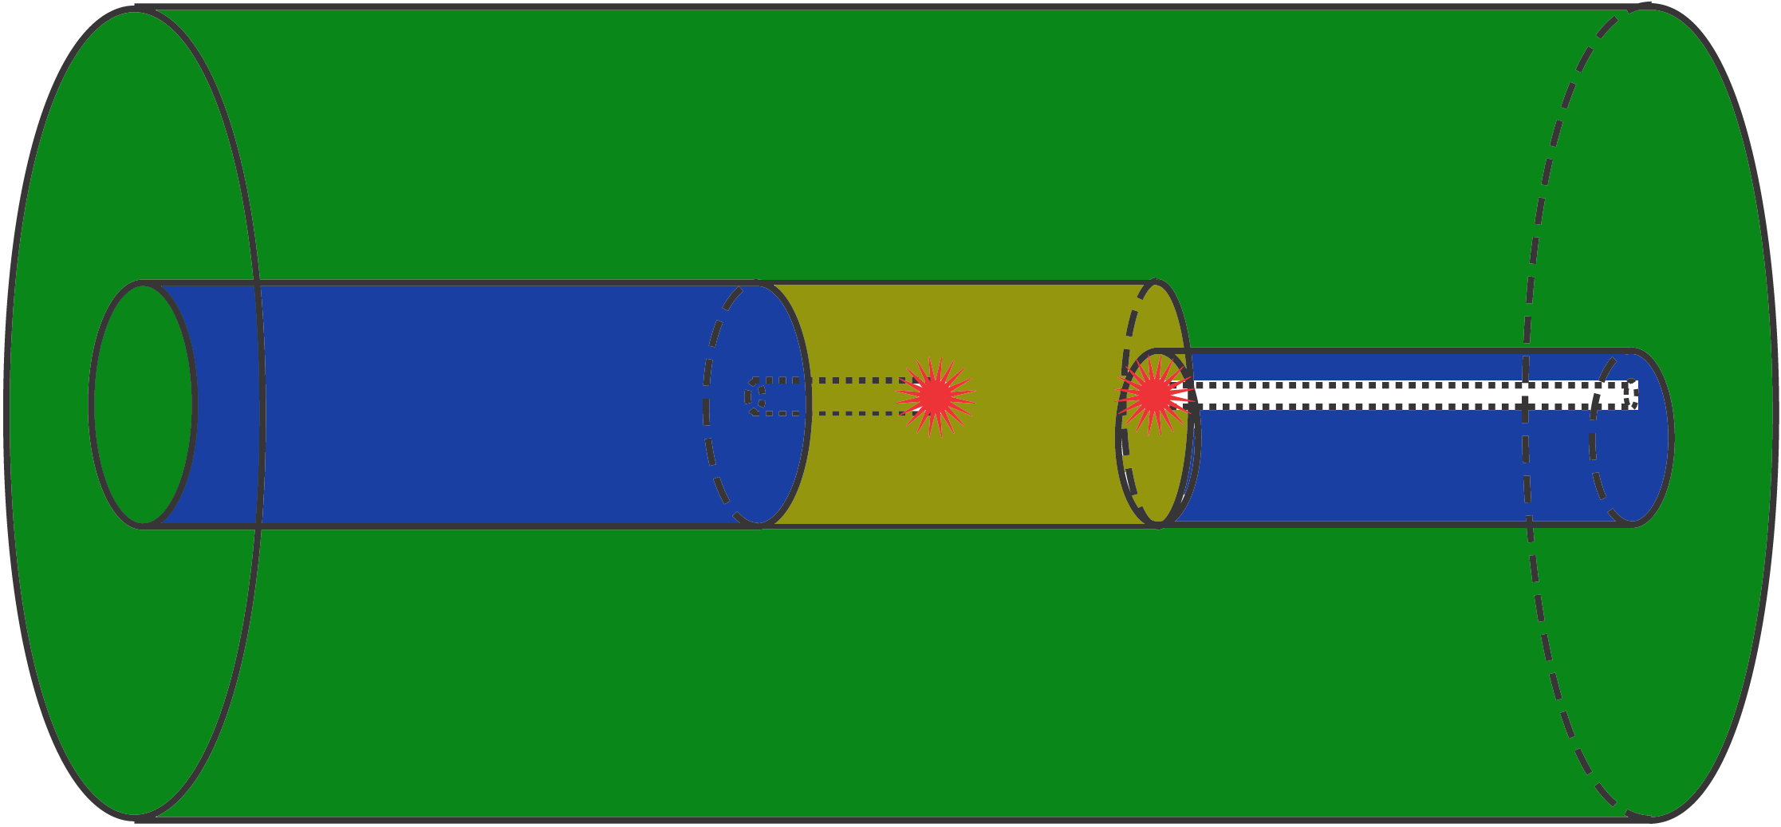
Polyethylene
Cf-252
Cs-137
Lead
Stainless Steel Liner
Radiation Window
Screw Top
Figure XXX
The Cf-252 sources is housed in the middle of a removable lead cylinder with a 3.4” diameter and 3.4” in length. The cesium source is to be placed at the base of this cylinder. Affixed to the lead cylinder is a 7.87” removable plug of polyethylene of similar radius to the lead cylinder. This plug allows for easy removal and replacement of the sources, ensuring long life of the system despite the relatively short half-life of Cf-252. At the base of the cylinder is a mechanically operated shutter capable of rotating outward when not in use for additional Cs-137 gamma shielding. The shutter features a 0.5” diameter passage that runs the expanse of the shutter cylinder, allowing radiation to pass through unhindered when open. The shutter cylinder is 7.87” long and is composed of polyethylene.
Surrounding the inner source plug and shutter apparatus is a cylinder of polyethylene, 7.87” thick, with an outer housing of stainless steel, 0.5” thick. The top of the canister features a pressure-resistant screw cap to allow for the removal of the polyethylene and lead plug containing the sources.
The detector to be used will be a 3x3 NaI (Tl) scintillator, such as the model 802 marketed by AREVA Canberra©. The electronic setup will mirror that of the experimental setup. The detector will receive 850V from a high voltage source. The photomultiplier connected to the detector will then enter a pre-amp, which will pass the signal to the surface platform and into a spectroscopy amp and then to the computer-based MCA, which will generate a spectrum of counts versus energy.
During the production stages of the Flow Analyzer package, CEARCPG will be utilized to generate a series of composite libraries specific to the design specifications of the Flow Analyzer and computed at an array of system pressures. Determining composite libraries at an array of system pressures – and therefore densities – will allow for accurate analysis at any pressure, despite changes in spectrum appearance that may occur (methane density will fluctuate depending on the depth at which the system is operated). The computing system at surface will receive a pressure reading from the Flow Analyzer, and will select composite libraries generated at the methane density associated with that pressure to be used in the comprative analysis.
As in the bench-top design study, MCLLS will be applied to compare the intensity of the detected spectra versus the appropriate composite libraries in order to determine the relative composition of the elements in the multiphase flow. It is expected that sample spectra may be gathered from the live data and fitted with the library data to generate an approximate sample composition in a recurring, constantly updating fashion.
To decrease dead-time and to increase efficiency of the system, windows will be set to bound strong peaks at transmission energies for certain elements, as listed in Table XXX. The energies given below are recommended because they are the strongest for the prompt gamma capture reactions (Molnár, 2004).

Isotope  (after neutron capture) | Energy (keV) | Sigma | Uncertainty
2-H | 2223.248 | 0.3326 | 7.00E-04
13-C | 1261.765 | 0.00124 | 3.00E-05
13-C | 3683.92 | 0.00122 | 3.00E-05
13-C | 4945.301 | 0.00261 | 5.00E-05
15-N | 1884.821 | 0.0147 | 1.80E-04
15-N | 5269.159 | 0.0236 | 3.00E-04
15-N | 10829.12 | 0.0113 | 8.00E-04
24-Na | 90.992 | 0.235 | 3.00E-03
24-Na | 874.389 | 0.076 | 1.10E-03
33-S | 2379.661 | 0.208 | 5.00E-03
33-S | 5420.574 | 0.308 | 7.00E-03
36-Cl | 517.073 | 7.58 | 5.00E-02
36-Cl | 1951.14 | 6.33 | 4.00E-02
36-Cl | 1959.346 | 4.1 | 3.00E-02
Table XXX – Energies of characteristic gamma rays generated by post-neutron-capture isotopes of interest, along with their standard deviation and uncertainty.
The spectral line of 517 keV for Cl-36 will not be used since it lies so closely to the annihilation gammas’ energy of 511 keV. Also, the 90 keV sodium peak might be discarded if lower energy gammas are discriminated out to reduce dead time.

DISCUSSION

1. Data analysis

2. Error analysis

a. Dead time
b. Homogeneity of phases
c. Code modeling assumptions

3. Suggestions for improvement of follow-up studies

CONCLUSION

1. Results Overview

a. Conclusions on viability of CEARCPG

2. Final apparatus design

a. Cost analysis

3. Further studies

- Introducing a mixing device
- Coincidence counting

REFERENCES

Hyne, N. J. (2001). Nontechnical Guide to Petroleum Geology, Exploration, Drilling, and Production, 2nd Ed. Tulsa, OK: Penn Well Corporation.
W. C. Lyons & G. J. Plisga (Eds.). (2005). Standard Handbook of Petroleum & Natural Gas Engineering, 2nd Ed. Burlington, MA: Elsevier.
Molnár, G. L. (Ed.). (2004). Handbook of Prompt Gamma Activation Analysis with Neutron Beams. Dordrecht, The Netherlands: Kluwer Academic.
Olivera, C. et. al. (1992). Prompt Gamma-ray Neutron Activation Analysis of Cement Raw Materials. Nuclear Geophysics 7 (3). pp.431-443.
Holmes, J. L. & Zoller, W. H. Prompt Gamma-Ray Spectroscopy for Process Monitoring. ACS Symposium Series 508. ACS 1992.
Cutmore, N. G. et. al. (1993). On-line Analysis of Coal. Nuclear Geophysics 7 (4). pp. 519-528.
NFOGM & Tekna. Handbook of Multiphase Flow Metering. March 2005.
Han, X. H., R. P. Gardner, and W. A. Metwally, (2007), “CEARCPG: A Monte Carlo Simulation Code for Normal and Coincidence Prompt Gamma-ray Neutron Activation Analysis (PGNAA),” Nuclear Science and Engineering, 155, 1, 143-153.

Mutiso, A. M., G. A. Johansen, and R. P. Gardner, (2007), “Investigation of Prompt Gamma-Ray Neutron Activation Analysis for Determining Phase Amounts in Multiphase Flow,” 5th World Congress on Industrial Process Tomography, 979-985.

Hunt, A., and Bradbury, L. (1990). “Homogenizing and metering the flow of a multiphase mixture of fluids.” U.S. Patent 4,974,452, issued December 4, 1990.

Young, H. D., and R. A. Freedman, (2004), Sears and Zemansky’s University Physics, 11th Edition, Pearson Education & Addison Wesley, San Francisco, California, 1651-1652.

Wang, J., F. Li, and R.P. Gardner, (2008), “On the Use of Prompt Gamma-Ray Neutron Activation Analysis for Determining Phase Amounts in Multiphase Flow,” Center for Engineering Applications of Radioisotopes, North Carolina State University.

Gedon, S. and Fengi, R. “Cellulose Esters, Organic Esters.” Kirk-Othmer Encyclopedia of Chemical Technology. 2004. John Wiley & Sons, Inc. 3 April 2008. <http://www.lib.ncsu.edu:2761/emrw/9780471238966/kirk/article/orgagedo.a01/current/pdf>.

Balser, K. et. al. “Cellulose Esters.” Ullmann’s Encyclopedia of Industrial Chemistry. 2004. Wiley-VCH Verlag GmbH & Co. KGaA. 3 April 2008. <http://www.lib.ncsu.edu:2300/emrw/9783527306732/ueic/article/a05_419/current/pdf?hd=All,celluloid>

APPENDIX

